**How to Obtain Your North Dakota Substitute Teaching License**

*Thank you for your interest in being a substitute teacher in North Dakota! The information on this guide pertains to North Dakota’s licensing process.*

**Education Standards and Practices Board (ESPB) Licensing Agency Contact Information:**

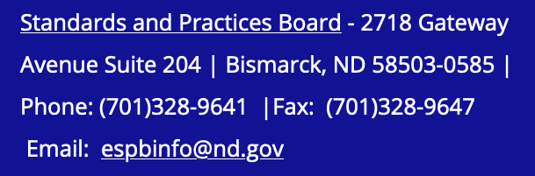

|  |  |  |
| --- | --- | --- |
| **Cost** | **Payment for…** | **Where/How to Pay** |
| **$8.00** | **Official Transcripts** | You must have a major credit/debit card (Visa, MasterCard, or Discover) and a valid email account to request your transcript online. (**See Step 1)** |
| **$44.50** | **Fingerprinting/aka background check** | ***Must* be a money order (you can get money orders from any bank, Walmart, *some* grocery stores and gas stations) (See Step 2)**  This is *not* the same background check required for clinicals. |
| **$30** | **One-time application fee** | **Paid and charged when you submit your application online (See Step 3)** |
| **$85** | **Substitute License** | **Charged when your substitute license is issued. Select Initial Educator License Interim Substitute License (Do not select ‘*permit’*)** |
| **Total Cost**  **$167.50** |

**(Initial) Educator License (not ‘*permit’*) Interim Substitute License (Two-Year)**: Issued to individuals with a minimum of 48 semester hours of college coursework. There is a $30 one-time application fee charged at time of applying; the license itself $85 substitute license (charged when issued). The license is good for a period of 2 years and expires on the applicant's birthday. A substitute license allows a person to be a substitute teacher grades K-12 in all ND schools.

**Use this web address to complete/submit information explained in the 3 steps:**

<https://secure.apps.nd.gov/dpi/ndteach/Login.aspx>

# Obtain Your Substitute License in 3 Steps

1. Official transcript documenting a minimum of 48 semester hours of college coursework (you must select to have the transcripts emailed/sent to ESPB).

**How to order official transcript (currently enrolled MSU students):**

**The following information can be found at** <https://www.minotstateu.edu/records/registrars-office-faq.shtml>

Minot State University has authorized **Parchment** to provide official transcript ordering securely online at any time. You must have a major credit/debit card (Visa, MasterCard, or Discover) and a valid email account to request your transcript online.

The online service allows you to:

* Order as many transcripts as you like in a single session.
* Track your order status
* Receive timely email notices regarding your transcript request
* Review your order status history

Check out our [video](https://www.youtube.com/watch?v=xGOL_ycGSp0&feature=emb_logo) or follow these steps:

1. Log into [Campus Connection](https://studentadmin.connectnd.us/psp/NDCSPRD/EMPLOYEE/HRMS/?cmd=login).
2. Click on Academic Records Tile.
3. Click Official Transcript Request on the left.
4. Choose Minot State University in the dropdown box.
5. Click Order Official Transcript button (This will direct you to the Parchment secured site). Select to have your official transcript emailed to ESPB at 🡪 [**espbinfo@nd.gov**](mailto:espbinfo@nd.gov)
6. Complete the request process.
7. Successful background check completed with ESPB. Background check instructions found [**here**](https://www.nd.gov/espb/sites/www/files/documents/Complete-Fingerprinting-Instructions-1-16-20.pdf).

Visit Deb Ringham in Swain Hall 218 for the packet and further help with completing this step. It takes about 2-3 weeks to get fingerprinting (aka background check) results. Results will be emailed to you and ESPB. This is *not* the same background check required for clinicals.

1. Online application for the substitute license. Click [**here**](https://secure.apps.nd.gov/dpi/ndteach/Login.aspx) to begin your online application.

**Do not select “Teaching Permit”. It typically takes about 3-4 days to get your license processed once ESPB receives all necessary information from the three-step process. Your license will be emailed to you for you to print.**

**Once at the website:**

* **Create an account by selecting “Register Now!”**
* **Once account is created, select “Begin New Application” in column on left side of page.**
* **Select “Initial Educator’s License”**
* **Select “Yes” if you have submitted other information (such as the fingerprinting even if you haven’t heard back yet from those results).**
* **Select “Initial Interim Substitute”**

**Once your license arrives via email, get on some sub lists! ☺**

**How to Get Substitute Positions in Area Schools**

*\*Note: This is not an exhaustive list but has information most recently verified by MSU faculty. In order to help keep this information up-to-date, please email Chelsie Hultz at* [Chelsie.Hultz@MinotStateU.edu](mailto:Chelsie.Hultz@MinotStateU.edu) *with any additional schools’ information/updates you find during your subbing journey Thank you!*

* **Berthold Public School 🡪 $140/day + free hot lunch 701-453-3484**
* Call to give name and phone number. They will call you when needed and first time out bring copy of substitute license, driver’s license, social security card, and a voided check.
* **Burlington Elementary 🡪 $140 full day/$70 ½ day + free hot lunch 701-839-7135**
* Call to give name and phone number. They will call you when needed and first time out bring copy of substitute license, driver’s license, social security card, and a voided check.
* **Max Public School** 🡪 **$130 full day + free hot lunch 701-679-2685**
* Call to give name and phone number. They will call you when needed and first time out bring copy of substitute license, driver’s license, social security card, and a voided check.
* **Minot Public Schools 🡪 $140 full day/travel pay for Air Force Base**
  + Online application (it will ask you to include 3 letters of recommendation, but for *subbing only* it *is acceptable* to upload a word document all three times stating “Available upon request”)

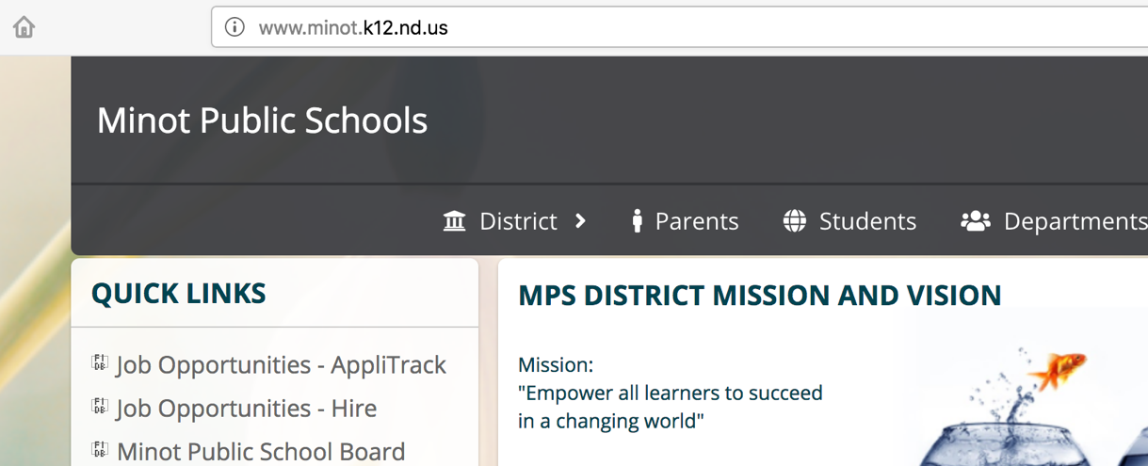

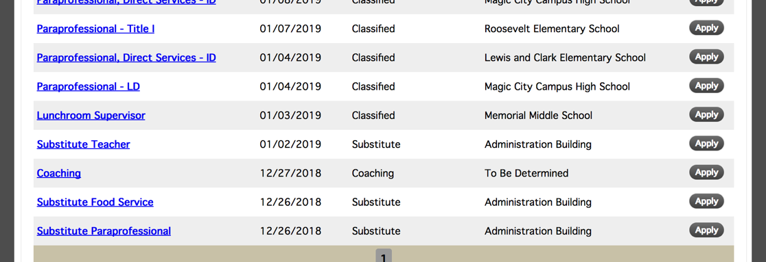

* Call 857-4404 Sarah for direct deposit and other things such as AESOP
* Sarah will meet with you then to discuss how to navigate MPS subbing.
* **Our Redeemer’s Christian School (Minot) 🡪** email [**office@orcsknights.org**](mailto:office@orcsknights.org)for a substitute application
* **South Prairie 🡪$140/day + free lunch 701-722-3537** 
  + Call to give your name and phone number to be added to their sub list. They will call you when needed and first time out bring copy of substitute license, driver’s license, social security card, and a voided check.
* **Surrey Public School 🡪 $140/day + free lunch 701-838-1262** 
  + Call to give your name and phone number to be added to their sub list. They will call you when needed and first time out bring copy of substitute license, driver’s license, social security card, and a voided check.

**PROVISIONAL LICENSE (before your degree is posted):**

If you plan to take a long-term sub position (more than 30 consecutive days) prior to receiving your actual teaching license, you are ***required by law*** to apply for and receive a 40 Day Provisional License. There is a fee for it that is separate than the substitute and regular license fees. Visit the top link to find details.

**TEACHING LICENSE:**

Teaching license initial 2-year ($70 charged when issued); $75 each endorsement issued (charged when issued)

*Minor in an area (such as mathematics) on transcripts is added as an endorsement on license automatically without extra fee.*

Answers to *Frequently Asked Questions* are provided for you at:

<https://www.nd.gov/espb/licensure/license-information/license-faqs>

The following information can be found at <https://www.nd.gov/espb/licensure/license-information/types-licenses>

**Types of Licenses in ND**

|  |  |
| --- | --- |
| **Initial Licenses** | **Renewal Licenses** |
| Initial In-State License | Two Year Renewal or Five Year Renewal |
| Initial Interim Substitute License | Interim Substitute License Renewal |
| Initial Out-of-State Reciprocal License | Out-of-state Reciprocal License Renewal |
| Alternate Access License | Alternate Access License Renewal |
| Initial Other State Educator License (OSEL) | Other State Educator License Renewal |
| (Available in 2 and 5 year) | Probationary License |
| 40-day Provisional License | Re-entry License |
|  | 30 Year Life License |

**Grade Configurations:**

**Early Childhood**: Birth – Grade 3 (B-3)

**Kindergarten**: Prekindergarten and Kindergarten (PreK-K)

**Elementary Education**: Grade 1- Grade 8 (1-8)

**Secondary Education**: Grade 5 – Grade 12 in the specific content area only (5-12)

The following content areas are PreK – Grade 12: art, foreign language, music, physical education, and computer education.

**License Descriptions:**

**Initial In-State License (Two-Year)**: Issued to first-time applicants who have met all of the ND requirements for licensure.

**Two Year Renewal (Two-Year)**: Issued to applicants with less than eighteen months of successful contracted teaching in North Dakota, those who have completed all requirements of a Probationary License, or those who have met all the requirements of an Out of State Reciprocal License.

**First Five Year License (Five-Year)**: Issued to individuals who have met all of the requirements for a ND Educator's Professional License and have successfully taught 18 months (full-time equivalent) in the state of North Dakota.

**Five Year Renewal License (Five-Year):** Issued to individuals holding a 5 year license - must be under contract at least thirty days of the five-year period and complete six semester hours of re-education to renew the 5 year license.

**Alternate Access License (One-Year)**: Issued in a documented shortage area. This license is for those who do not have a teaching degree but do have a bachelor’s degree in a content area where the vacancy exists in the school. It is expected that the applicant will work with a university to complete their education coursework over the next 3 years (if needed.) The license must be requested in writing by the local school administrator indicating the unsuccessful search for a qualified applicant and the desire for this license to be issued. Requirements include the completed online application, a bachelor’s degree in the content area to be taught (official transcripts), and a plan of study from the college of education where the applicant will complete 1/3 of the program of study each year toward the teaching degree. This license can be issued a year at a time for a maximum of 3 years.

**Interim Substitute License (Two-Year)**: Issued to individuals with a minimum of 48 semester hours of college coursework. License is good for two years and now expires on the applicant's birthday.

**Initial Alternate Pathway License - American Board (Two-Year)**: Issued to applicants who have completed the requirements of American Board for North Dakota licensure.

**Out-of-State Reciprocal License (Two-Years)**: Issued to individuals who graduated from an out-of-state university but do not hold a teaching license in another state. A transcript analysis is completed and a plan of study is developed for each individual indicating the coursework and testing needed. This license can be issued twice, so the educator has a total of four years to complete all requirements.

**Other State Educator License (OSEL).**A two or five year license issued to those applicants who hold and submits a valid teaching license received from an approved regular teacher education program from another state. If the applicant has not tested in the sending state and has been licensed after 2002 in that state, they will have two years to complete ND tests. The regular application will be submitted including official transcripts, completed background packet, a copy of your current teaching license from another state, and/or confirmation form or test scores. If you have completed an approved program, including student teaching, hold a license in another state and have met their testing requirements, there will be no additional requirements.

**Re-Entry License (Two-Years)**: Issued to individuals who have held a ND teaching license but it expired more than 5 years ago. A new background check is required. Eight semester hours of reeducation will be required if the applicant signs a contract during the license period.

**Probationary License (Two-Years)**: Issued to individuals who have not completed the reeducation requirements for the five year or re-entry license. Only one probationary license is issued to an applicant.

**40-Day Provisional License (40 Calendar Days)**: Issued to applicants who have been offered a job (either substitute or teaching) and have completed the entire application process with the exception of the background investigation. A letter from the school administrator indicating their desire to hire that person without the background investigation being complete and a letter from the applicant indicating their criminal background history is needed by the ESPB prior to issuing this license. [40-Day Provisional License Instructions](https://www.nd.gov/espb/40-day-provisional-license) (34kb pdf)

**30-Year Life License**: Issued to a teacher who has held a ND license for 30 years and met the requirements of their current teaching license. (If an applicant currently holds a 5-year license and would like to move into the 30-Year Life License, they must submit 6 semester hours of re-education credit as required for the 5-year license they currently hold.) **Expiration**: none