How to create an artifact for your background check for clinicals and admission!
Step One
Click on Artifact on the side.
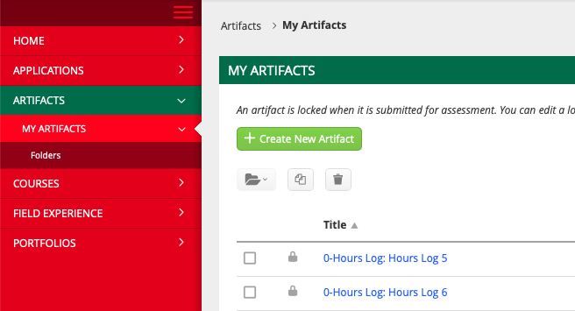

Step Two
Click on create new artifact.
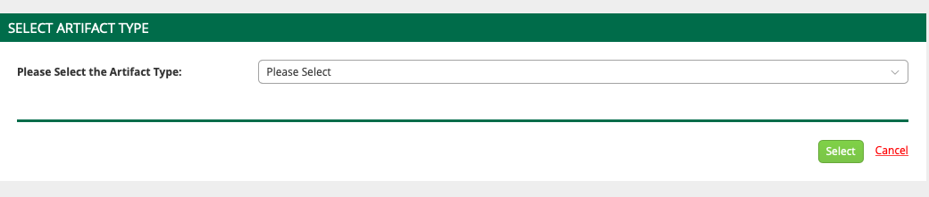

Step Three
Click drop down box and scroll until you see Background Check Clinicals and Admissions.
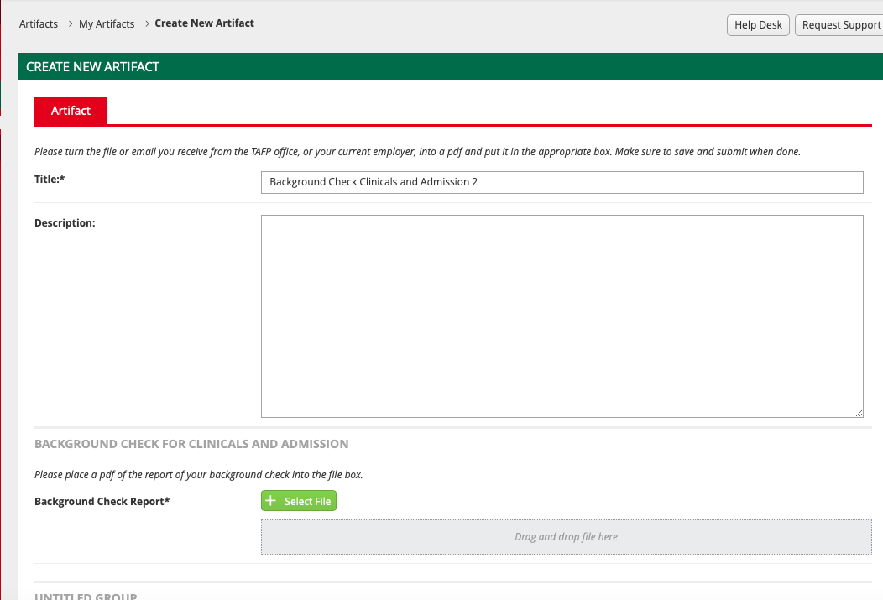

Step Four
Upload Background Check Report from select files.

Step Five
When done click the green button at the bottom of the page.

