Updating Campus Personal Information

- Log in to Campus Connection
- On your Faculty/Advisor Homepage you should see a Profile Tile: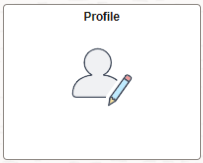
- If you do not have the Profile Tile:
  - In the top right corner, click on the 3 vertical dots, then click Personalize Homepage: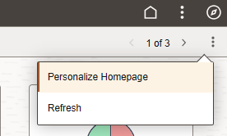
  - From this page, click Add Tile:
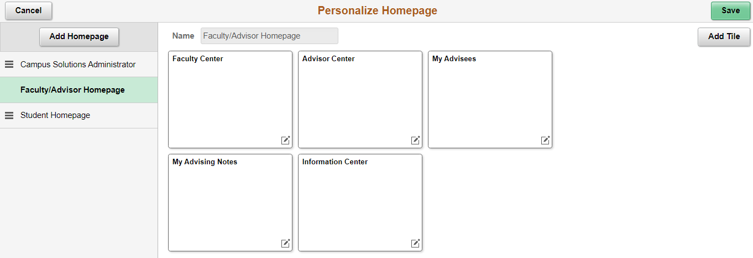
  - In the search box, type Profile and hit enter or the double right-facing arrows: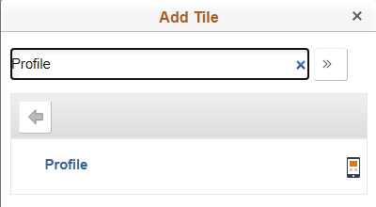
  - Click on Profile and it will add this tile to your homepage, then click Save and it will take you back to your Faculty/Advisor Homepage:
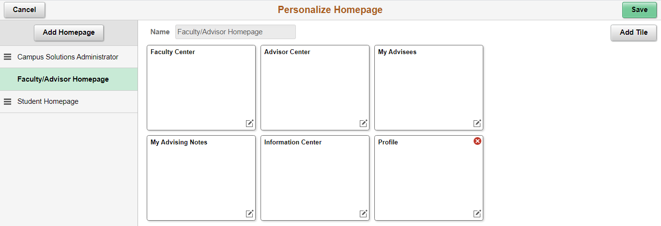
- To update your campus personal information, click on the Profile Tile
- Once here you will see a list of personal information. Some fields are editable while others are not. If there is a field you need to update but it is not an editable one, please contact the Registrar’s Office at 701-858-3345 or registrar@minotstateu.edu for assistance.
