How to Run a Transcript
- Login to Campus Connection and click the Student Records Tile, and then on the left click Request Transcript Report.
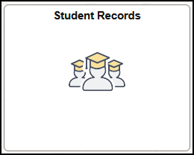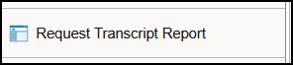
- On the top right, click the Add a New Value button.
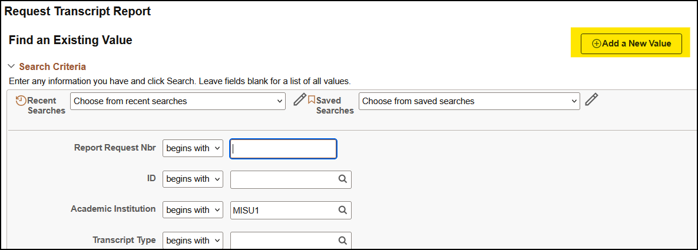
- On the Transcript Request Header tab, you can choose your transcript type.
  - In the Transcript Type drop down
    - Choose ADVIX for an advising transcript
    - Choose UNOFX for an unofficial transcript
    - In the Future Release drop down, choose Immediate Processing.

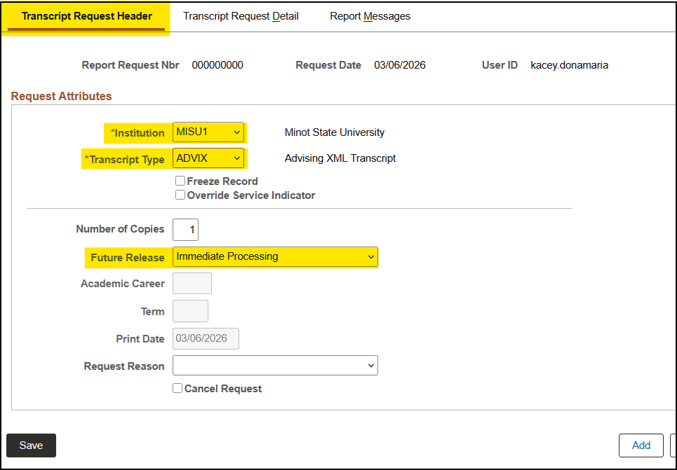

- On the Transcript Request Detail tab, you will put in the student’s details.
  - Type the student’s ID number in, or use lookup icon to search for the name. Then click Process Request button.
  - TIP: You can click the Add a Row button on the right side to process multiple transcripts at a time.
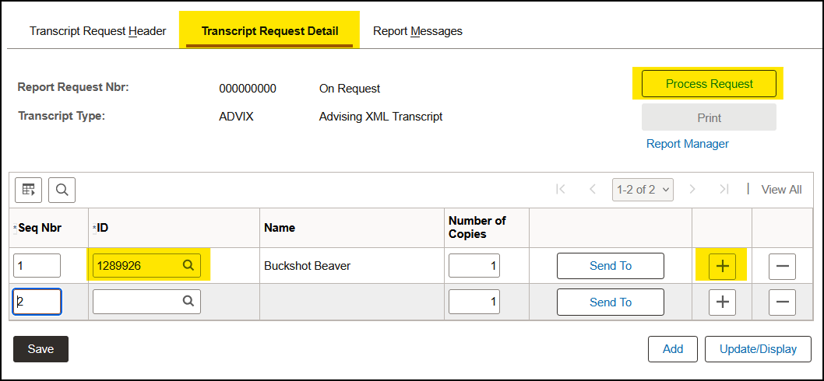
- Once processed, click View Report link. The transcript will pop up in a new window or tab. You may need to turn your pop-up blocker off if you have one or the transcript will not appear.
