How to Evaluate a Registration Action Form

Option 1:
- Login to Campus Connection
- Click on the MiSU eForms tile.

- Click Evaluate an eForm in the left-hand menu.

- Click the Search button.

- All forms that you need to review will appear.
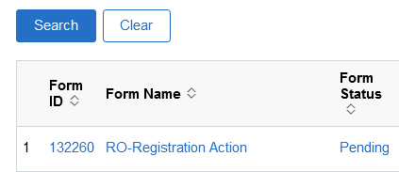
- Click the first form.
- Review the form and make sure you are the instructor for the course and that the correct chair is entered if a chair is required.
- Double check all the information on the form for accuracy. If anything is incorrect, you can recycle or deny the request. If you are going to recycle or deny, please add a comment in the appropriate feedback section to let the student know why and if recycling, what to fix and then resubmit.
- Click Approve, Deny, or Recycle. This sends the form on to the next approval step, or to the Registrar’s Office for processing.

Option 2:
- Click the link in the email from the helpdesk.
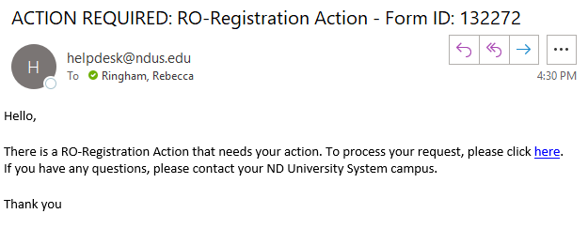
- Review the form and make sure you are the instructor for the course and that the correct chair is entered if a chair is required.
- Double check all the information on the form for accuracy. If anything is incorrect, you can recycle or deny the request. If you are going to recycle or deny, please add a comment in the appropriate feedback section to let the student know why and if recycling, what to fix and then resubmit.
- Click Approve, Deny, or Recycle. This sends the form on to the next approval step, or to the Registrar’s Office for processing.

Specific form information:

Change to or from S/U grading:
The S/U option is open to all students in good academic standing who have achieved junior-year status with 60 or more semester hours. Students on Academic Warning or Academic Probation are prohibited from pursuing this option.
No more than 15 semester hours of elective S/U course work can be applied toward a baccalaureate degree. The S/U option may not be used in those courses to be applied to the student’s major, minor, General Education requirements, or the professional education sequence. However, one S/U course may be applied to each area of concentration.

Elect audit grading:
No credit is awarded for an audited course, and an auditor may not later establish credit in that course by taking a special examination.

Override into Class:
If you approve, this overrides both pre-requisites and a closed or full class.

Time Conflict:
The student will fill in the instructors for both courses.

Time Conflict after last day to add:
The student will fill in the instructors for both courses. If you are the second instructor, you will need to add the chair information for approval.

