How to Evaluate a Registration Action Form

Option 1:
- Login to Campus Connection.
- Click on the MiSU eForms tile.

- Click Evaluate an eForm in the left-hand menu.

- Click the Search button.

- All forms that you need to review will appear.
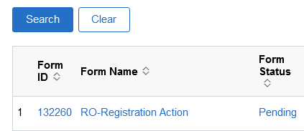
- Click the first form.
- Review the form and make sure you are the correct chair for the entered course.
- Double check all the information on the form for accuracy. If anything is incorrect, you can recycle or deny the request. If you are going to recycle or deny, please add a comment in the appropriate feedback section to let the student know why and if recycling, what to fix and then resubmit.
- Click Approve, Deny, or Recycle. This sends the form on to the next approval step, or to the Registrar’s Office for processing.

Option 2:
- Click the link in the email from the helpdesk.
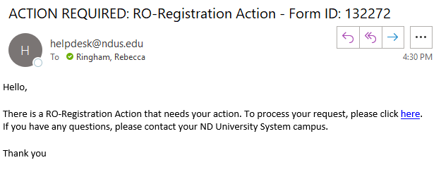
- Login to Campus Connection if you are not logged in.
- Review the form and make sure you are the correct chair for the entered course.
- Double check all the information on the form for accuracy. If anything is incorrect, you can recycle or deny the request. If you are going to recycle or deny, please add a comment in the appropriate feedback section to let the student know why and if recycling, what to fix and then resubmit.
- Click Approve, Deny, or Recycle. This sends the form on to the next approval step, or to the Registrar’s Office for processing.

Specific form information:

Add after the deadline:
If you approve, this overrides both pre-requisites and a closed or full classes.

Time Conflict after last day to add:
The student should fill in the instructors for both courses and the chair.

