Mass Assign Service Indicators
- Prepare the excel file with all your student ID numbers.
  - The file must be saved in CSV format and must contain the preceding 0 so that all the IDs are seven digits long.
    - To add the preceding 0, highlight all the ID numbers, right click and select Format Cells.
    - In the Format Cells dialog box, click Custom.
    - Type seven zeros in place of the word General. So that the sample text shows seven digits.
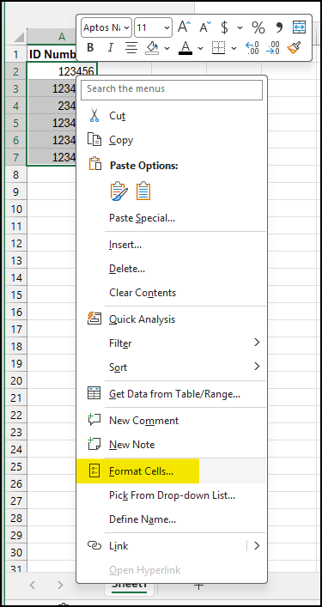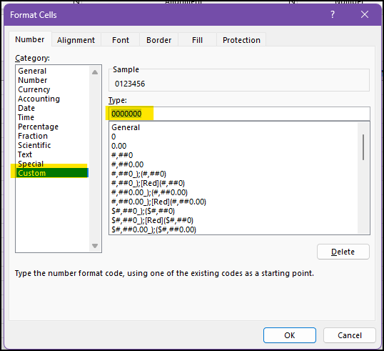
  - Save your file as a CSV (Comma delimited) document.
- In Campus Connection, click the Campus Community tile.
- In the left menu, click Service Indicators and then click Mass Assign.
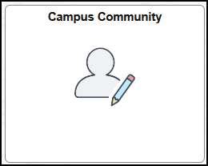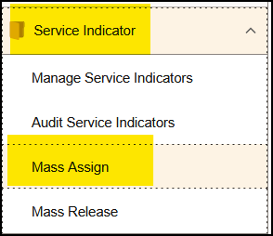
- The first time you run this process you’ll need to create a Run Control ID, but if you have done it before you can search for your previously used Run Control.
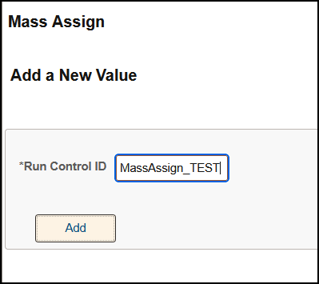
- Enter data in the following fields:
  - Choose External File under Selection Tool.
  - Upload your CSV file by clicking the Upload File button.
  - Choose SERVICEINDICATOR under File Mapping.
  - Choose Minot State University under Institution.
  - Choose the Service Indicator Code and Reason for the hold you would like assigned.
  - Choose Start Term and Start Date.
    - Normally, this is the subsequent term, so if placing holds during Spring 2026, the start term should be 2640 for Summer 2026. Please double check the date you want the hold to take effect before assigning the holds.
  - Choose End Term and End Date if you would like a specific time the hold should be released.
  - Make sure your Department Number is correct, and add your Contact ID.
  - You can also add Comments to go on the holds, but please be aware that comments are NOT SEEN by the student, only by faculty and staff.
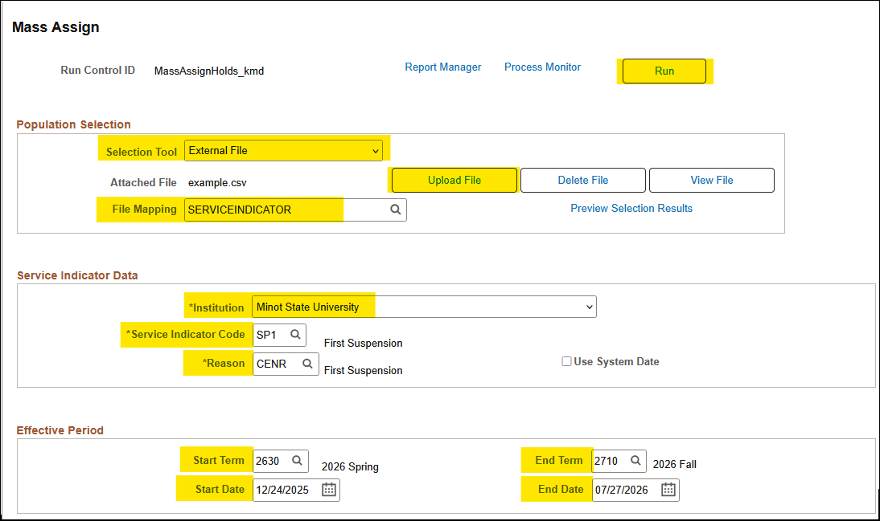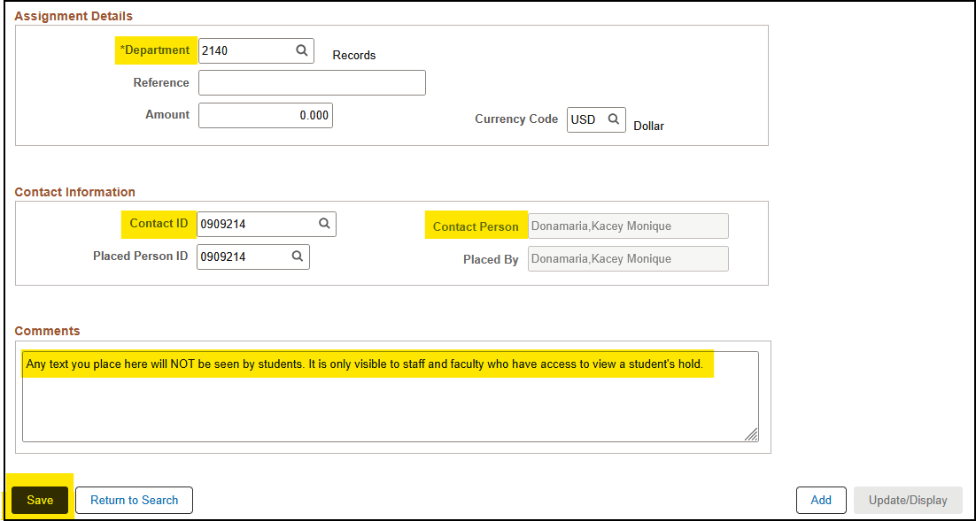
- Once you’ve verified all the information is correct, click the Run button at the top right to assign the holds. On the next screen, click the OK button.
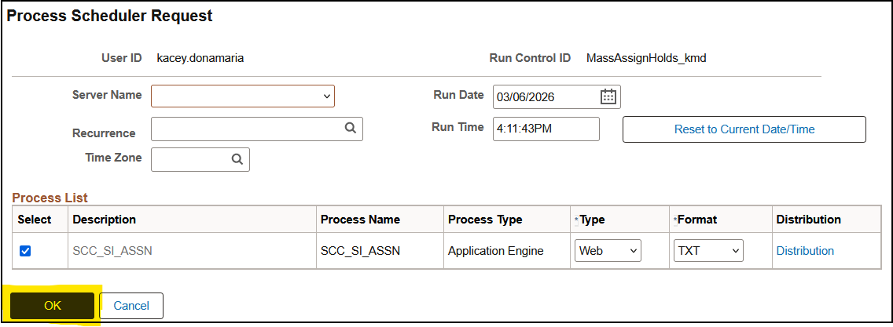

Mass Release Service Indicators

- Prepare your CSV file (see instructions above).
- Log in to Campus Connection and click on the Campus Community tile.
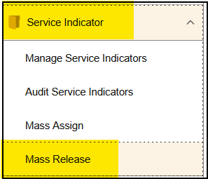
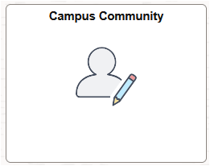

- In the left menu, click Service Indicators and then Mass Release.
- The first time you run this process you’ll need to create a Run Control ID (see instructions above), but if you have done it before you can search for your previously used Run Control.
- Enter data in the following fields:
  - Choose External File under Selection Tool.
  - Upload your CSV file by clicking the Upload File button.
  - Choose SERVICEINDICATOR under File Mapping.
  - Choose Minot State University under Institution.
  - Choose the Service Indicator Code and Reason for the hold you would like released.
- Once you have verified all the information is correct, click the Run button at the top right of the screen, and on the next screen click the OK button.

