How to Submit a Substitution Form

- Log in to Campus Connection.
- Click the MiSU eForms tile.

- Open the Registrar’s Office folder in the menu on the left.
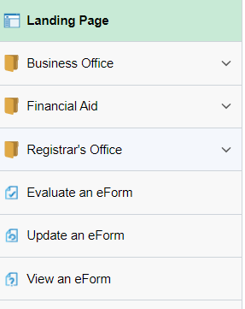
- Click Admin-Course Substitution.

- Enter the Student Information: What the substitution is for, student program (major/minor/concentration/gen ed), student EMPLID, and Term.
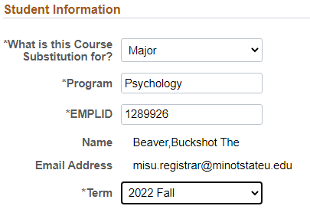
- Enter the Course Substitution Information: Institution, Course Subject, Course Catalog Number, MiSU Course Name, MiSU Subject, and MiSU Catalog Number
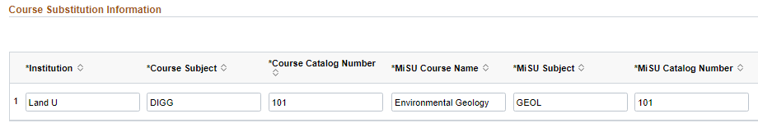
- Click the plus sign button to add more courses

- Look up the Department Chair by clicking on the magnifying glass.

  - Open the Search Criteria by clicking the triangle to the left.
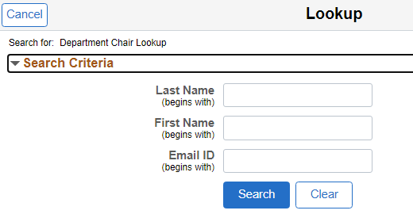
  - Enter the first few letters of the chair’s Last Name and First Name and click the Search button.
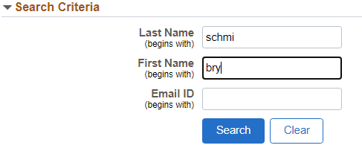
  - Find the correct chair and click on their name.
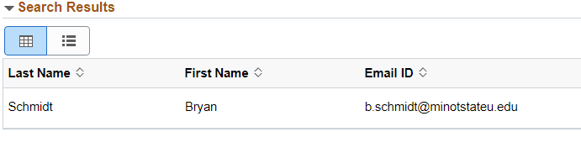
- Change the toggle to Yes on the Acknowledgement.
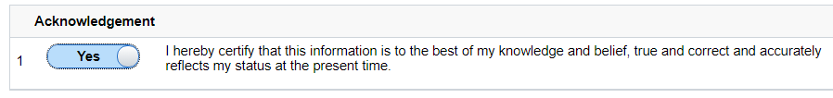
- Click the Submit button.

