How to Release an Advisee’s Hold

- Log in to Campus Connection.
- Click the Advisor Center tile.
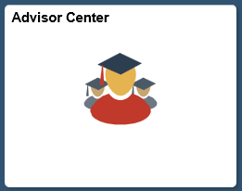

- Click the View Student Details link next to the student for which you would like to remove the hold.
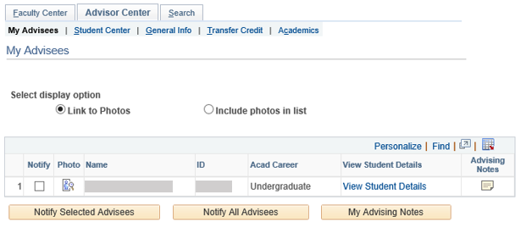

- Click the General Info tab at the top of the page.
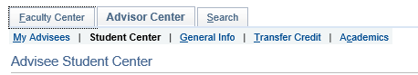

- Click the Edit Service Indicators button.
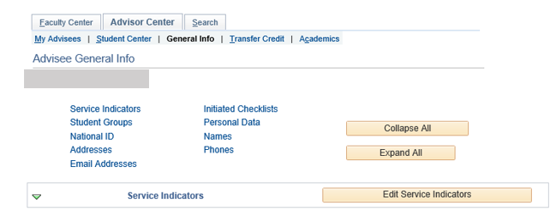

- Click the link next to the hold you would like to remove.
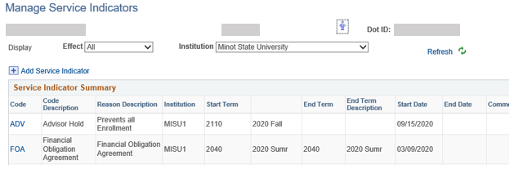

- Click the Release button.
