How to Evaluate the Course Completion Agreement Form
As a reminder, an incomplete grade may be requested by a student who has been in attendance, has done satisfactory work (C or better) during the term, and whose work is incomplete for reasons found to be satisfactory to the instructor according to MSU policy.
Course Completion Agreements must be approved and received by the Registrar’s Office by the deadline when grades are due.

Option 1:
- Login to Campus Connection
- Click on the MiSU eForms.

- Click Evaluate an eForm in the left-hand menu.
- Click the Search button.
- All forms that you need to review will appear.
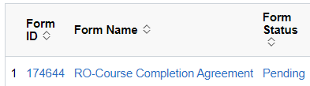
- Click the first form.
- Review the form.
- Click Approve, Deny, or Recycle. If you recycle or deny the request, please add a comment in the feedback section before pushing the button to let the student know why and if recycling, what to fix and then resubmit.

Option 2:
- Click the link in the email from the helpdesk.
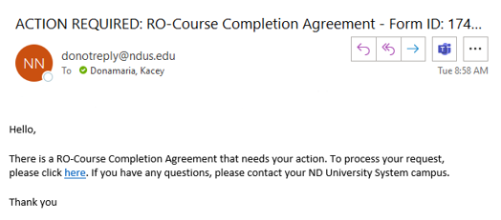
- Login to Campus Connection, if you are not logged in.
- Complete steps 2-8 above.

It’s best to check forms to evaluate at least once per week so they can be processed in a timely way.

