How to Enter Grades
- Login to Campus Connection.
- Click on the Faculty Center tile.

- Your schedule will display for the current term. If your teaching schedule does not appear for the correct term or institution, click the Change Term button, select the correct term and institution, and click the Continue button.
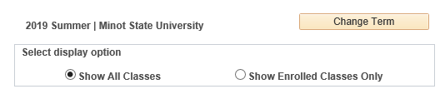
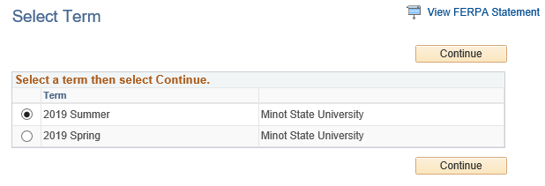
- Click the Grade Roster icon next to the class to enter grades for that class.
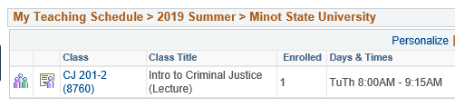
- Choose the correct grade roster: Mid-Term or Final in the Grade Roster Type dropdown.
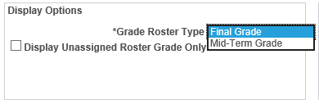
- Choose each student’s grade in the dropdown box next to the student’s name.
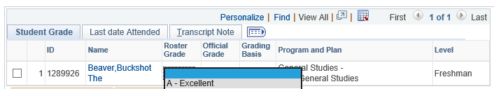
  - Please also be sure to use the FN grade for students who stopped attending the course. When using the FN grade, please enter the last date of academic participation on the Last date Attended tab.
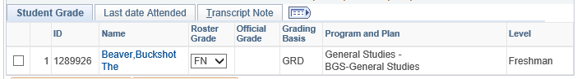
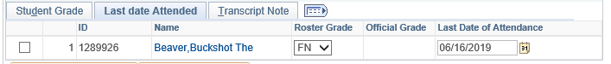
  - The FNN grade means failure for never attending and should not be used, since students are reported for non-attendance at the beginning of each and already removed from the course.
- Once all grades are entered, change the Approval Status to Approved and click the Save button.
