Faculty Campus Connection Quick Guide

Log into Campus Connection. Important tiles:

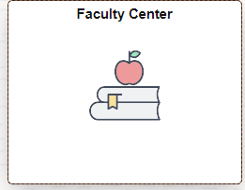
Faculty Center tile
- My Schedule
  - Click on Change Term to change terms or institutions
  - Click on the “Class” link (i.e. ACCT 201-1 (19803) to view course details)
- Class Roster
  - Click My Schedule in the left-hand menu
  - Click on the icon to the left of the course you wish to review
- Once in the roster, click on the student’s name or the box next to multiple students to generate an email to them.
- Grade Roster
  - Click My Schedule in the left-hand menu
  - Click on the icon to the left of the course you wish to submit
  - Select the Grade Roster Type (Mid-Term/Final)
  - Use the drop down box to assign a grade to each student
  - Change the Approval Status to Approved
  - Click Save
Detailed instructions are available on the Campus Connection How to website under Grade Reporting

MiSU eForms tile
- Submitting eForms:
- Under the Registrar’s Office folder in the left-hand menu, eForms faculty submit:
    - Admin-Course Substitution
    - Admin-Grade Change
- Evaluating eForms:
- Click Evaluate an eForm in the left-hand menu, then search button. Click on an eForm. Options after reviewing the eForm in full:
    - Recycle: if the student needs to update the form, enter feedback in the “Feedback to Requestor (Recycled)” box to tell the student what needs to be edited, then click this button to send the eForm back to the student to make updates.
    - Deny: enter feedback in the “Final Feedback to Requestor (Approved/Denied)” box to tell the student the reason for the denial, then click this to deny the eForm.
    - Approve: click this when you have reviewed and want to approve the eForm as it is with no feedback in either box.

- Updating eForms:
- Click Update an eForm in the left-hand menu, then search button. Click on an eForm.
    - This is how you update an eForm that you have submitted that has been recycled to you.

Setup User Defaults
  - Click on Navigator ()> Menu (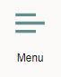)> Setup SACR> User Defaults

  - Enter MISU1 for the Academic Institution, Career Group SetID, and Facility Group SetID
