CC Grade Change Form

- Log in to Campus Connection.
- Click the MiSU eForms tile.

- Open the Registrar’s Office folder in the menu on the left.
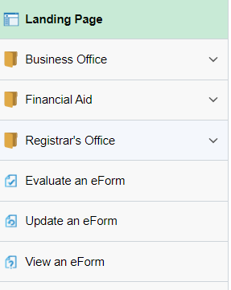
- Click Admin-Grade Change.

- Enter the Student Information: student EMPLID, Type of Change, Term, and New Grade.
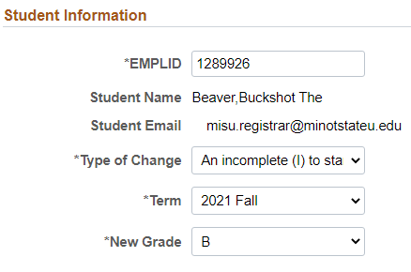
- If you know the 4-digit class number, enter it. If not, click the magnifying glass to search for the class.
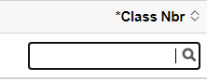
  - Open the Search Criteria by clicking the triangle to the left.
  - Delete the 0 in the Class Nbr field and use only the Subject Area to search for the correct section.
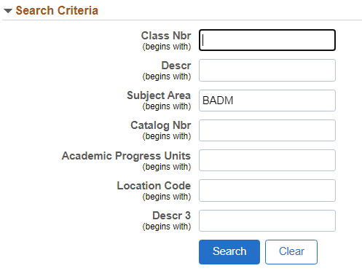
  - Click the Search button.
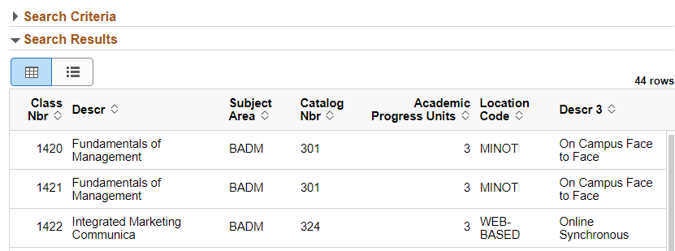
  - Find the correct section and click on it.
- Change the toggle to Yes on the Acknowledgement.
- Click the Submit button.

