Instructions for adding an advisor to a student in Campus Connection
- Once logged into Campus Connection, go to the Students Records Tile, and click on Enrollment and Records, then click on Student Advisor.
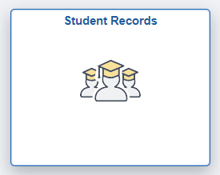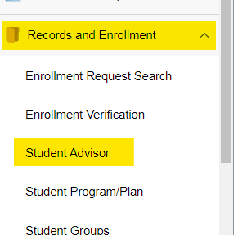
- You’ll need to search for the student using their EMPLID if you know it, or their last and first names.
  - The Academic Institution field needs to be MISU1.
  - The Academic Career should be either Undergraduate or Graduate depending on the student.
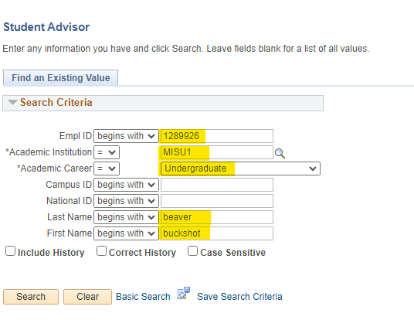
- Once you are in the Student Advisor page, click the button with a plus sign on it in the top most right corner of the Student Details section. This will add a new row with today’s date as the effective date, and will allow for the most accurate and updated student enrollment information to pull into the fields below.
- When you are adding an advisor for a brand new student, or a student who has changed their primary program, the Student Academic Details section should be blank, and you will have to fill in each of the required sections.
  - Advisor Role should always be Advisor.
  - Advisor Number: If they are the only advisor, make sure they are number 1. If they have multiple advisors then make sure they are in sequential order.
  - Academic Career should be either Undergraduate or Graduate depending on the student.
  - Academic Program is where you will put the student’s current primary program.
    - Use the magnifying glass to open the dialog box that will show all the student’s programs.
    - Make sure the one you are choosing says Active in Program in the Program Status. If it says Completed or Discontinued you will get an error message when you try to save.
  - Academic Plan is where you put the plan you are adding the advisor for. This might be a major/2nd major/minor/concentration. Make sure you are selecting the program you want, and again, make sure it says Active in Program.
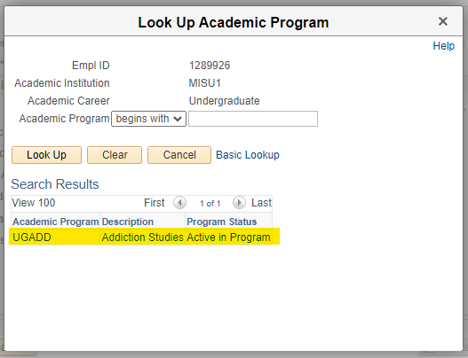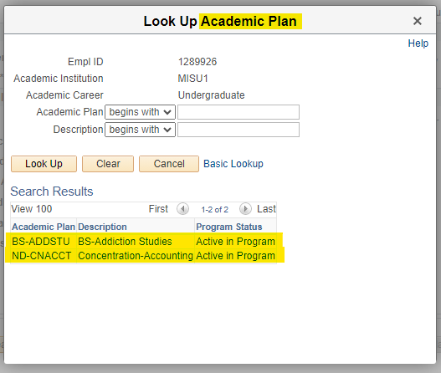
  - Academic Advisor: If you know the advisors EMPLID number you can type it in and hit enter to bring them up. If not, use the magnifying glass to search for them by their name.
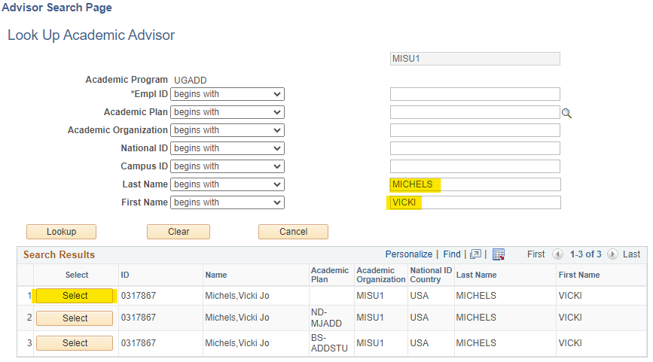
  - Once everything is filled in, click Save.
- If the student already has an advisor (example: their major is History and so they have an advisor for that) and you are adding an additional advisor to them for a secondary major, minor, or concentration, you must add a row under the Student Academic Details after updating the effective date. This will open an additional advisor section so you can add their new advisor using the same steps as above.
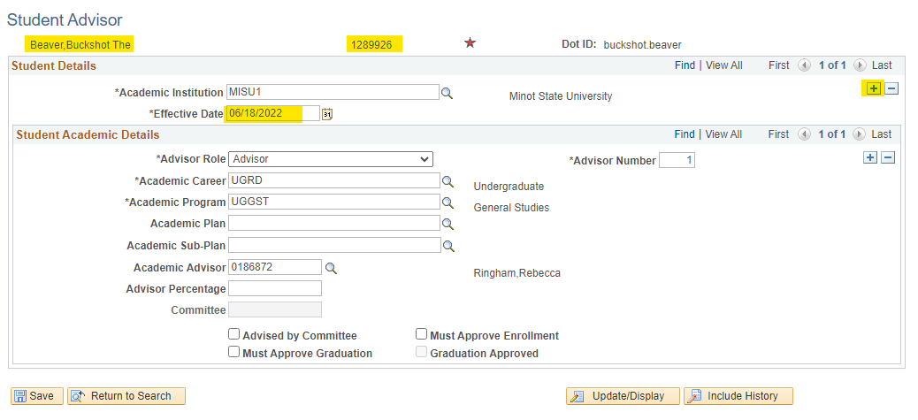
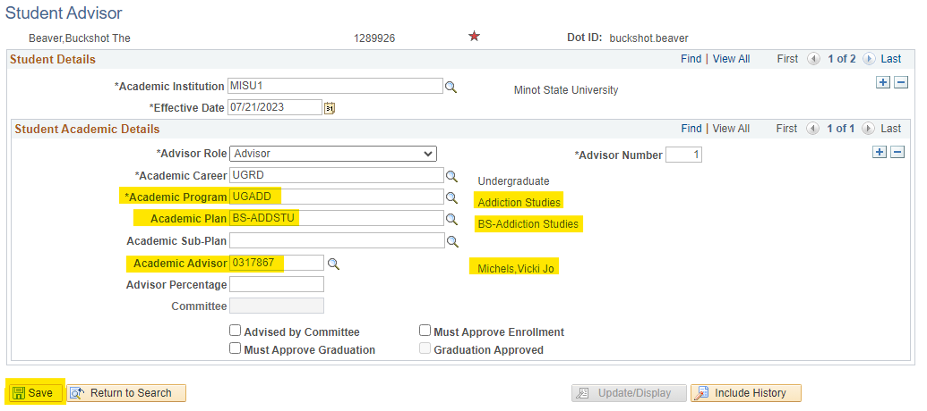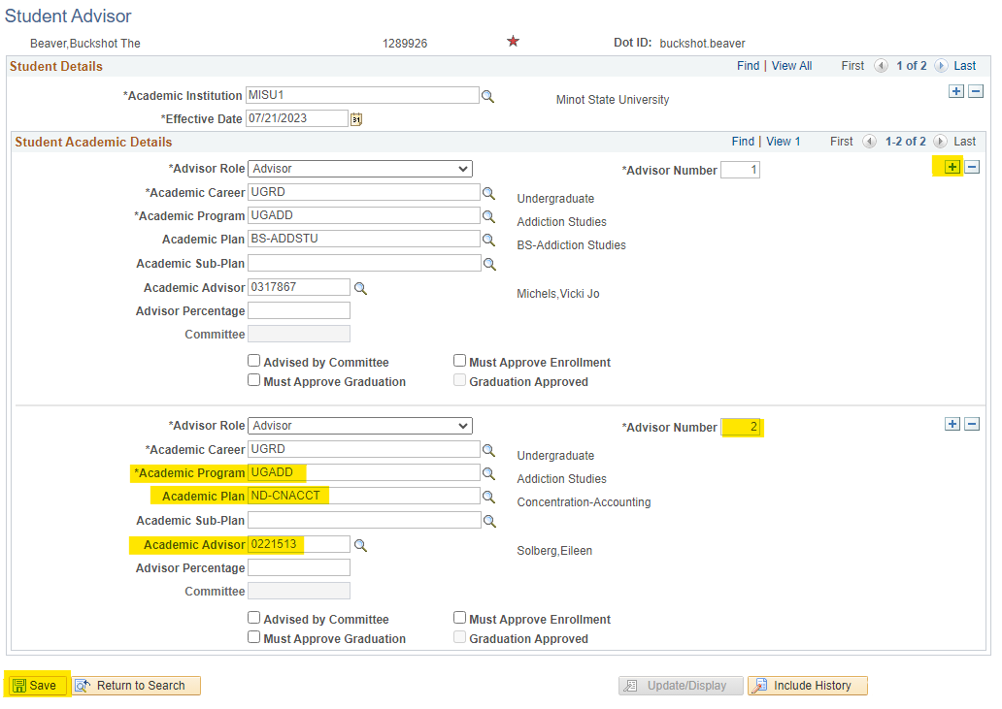

Troubleshooting
- If you’re trying to save and receive an error message reading, “An Academic Advisor or an Advising Committee must be specified. (14600,194) Either an Academic Advisor or an Advising Committee must be selected for each Advising Role before a record can be saved. Select a valid Academic Advisor or an Advising Committee then save the record.” there is a row under the Student Academic Details that has empty information.
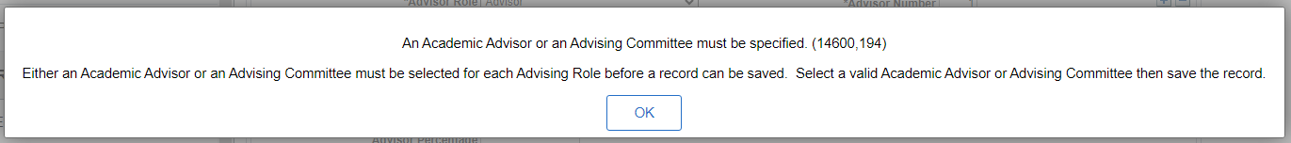
  - This frequently happens if the student previously had multiple advisors in multiple programs, and then when you update the effective date now the student only has one active program, those other rows stay and you will have to delete them.
  - Click on the View All link under the Student Academic Details and see if there is a row with blank information. If there is, you can delete the row by clicking the minus (-) sign in the top right corner of that specific row. Then you should be able to save like normal.
  - You should never delete a row that has information filled in unless it is for your department.
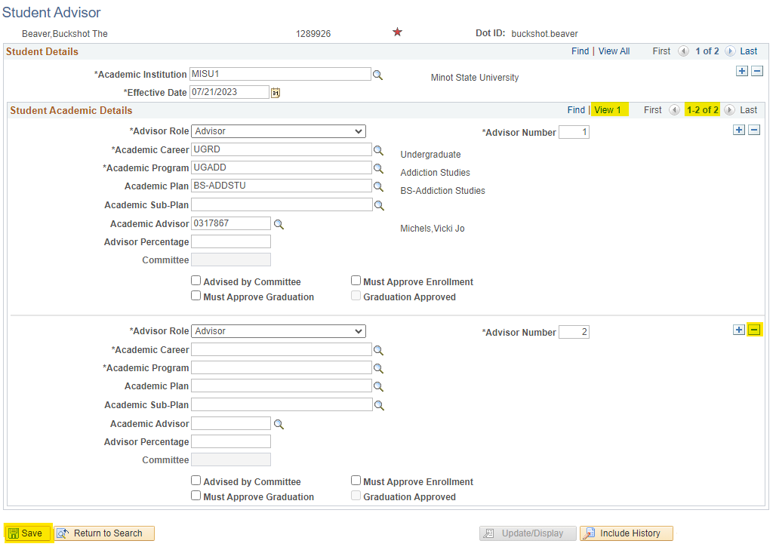
- If you’re trying enter an advisor’s ID number and receive an error message reading, “Invalid value – press the prompt button or hyperlink for a list of valid values (15,11). The value entered in the field does not match one of the allowable values. You can see the allowable values by pressing the Prompt button or hyperlink associated with field, which is currently focused.” it means that faculty member has not had their role set up to advise for that specific program/plan combination.
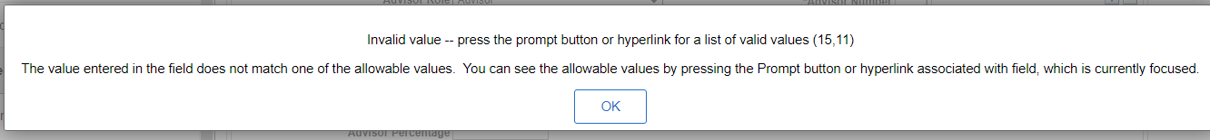
  - This may happen if a faculty member is new, or if a student has a program that a faculty member wouldn’t typically advise for. In this case you’ll need to contact the Registrar’s Office (at this time Kacey Donamaria) to update the advisor’s role before you are able to add them.
  - They will need an email with the student’s ID number, the advisor’s ID number if you have it, and what program/plan combination you want to advisor to be set up for.

