Data Metrics
- Formed as a result of Strategic Enrollment Management (SEM) project
- Comprised of :
  - IR Office (Cari Olson)
  - Registrar’s Office (Rebecca Ringham)
  - Enrollment Services Office (Katie Tyler)
  - Center for Extended Learning (Jolina Miller)
  - Financial Aid Office (Laurie Weber)
- Cohort Analysis
  - The concept of this report is to track cohort student enrollment through graduation
  - Data Metrics found that although we have Hobson’s this only tracks Inquiry to 1st year enrollment
  - Due to lack of software Data Metrics creates this report manually
  - Summer 2020 the following cohorts were ran and compiled
    - 2014
    - 2015
    - 2016
    - 2017
    - 2018
    - 2019
  - Additional Variables were brought in:
    - Credits attempted
    - Credits completed
    - Retention
    - Graduation
    - Student Tracker- National Student Clearing House Information (ran summer 2020)
  - Data Metrics created a Student Status Column based on Student Tracker
    - Graduated at a different institution
    - Graduated at MSU
    - Still enrolled at a different institution
    - Still enrolled at MSU
    - Stopped Out
    - Stopped Out and Returned
    - Transferred to another institution
    - Deceased
- It is the intent of the Data Metrics team to update the Student Cohort each summer once graduation data has been processed and available through Student Tracker.

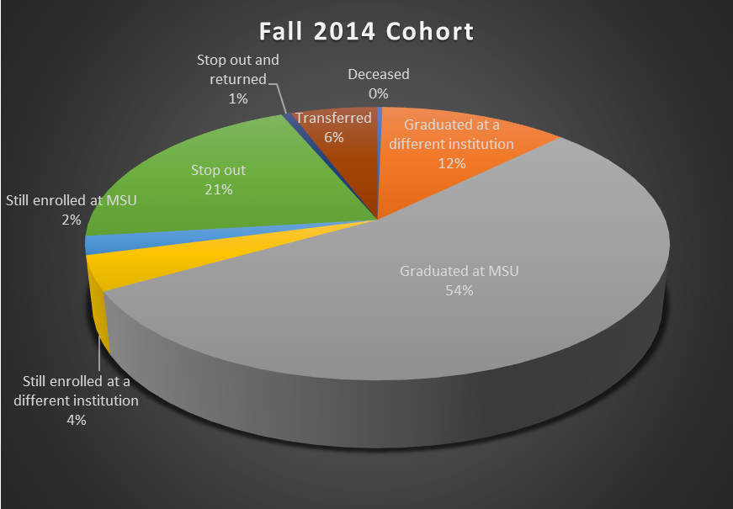
Fall 2014 Cohort | # | %
Deceased | 1 | 0.32%
Graduated at a different institution | 39 | 12.34%
Graduated at MSU | 171 | 54.11%
Still enrolled at a different institution | 13 | 4.11%
Still enrolled at MSU | 7 | 2.22%
Stop out | 65 | 20.57%
Stop out and returned | 2 | 0.63%
Transferred | 18 | 5.70%
Grand Total | 316 | 100.00%

6-year Graduation Rate=54%

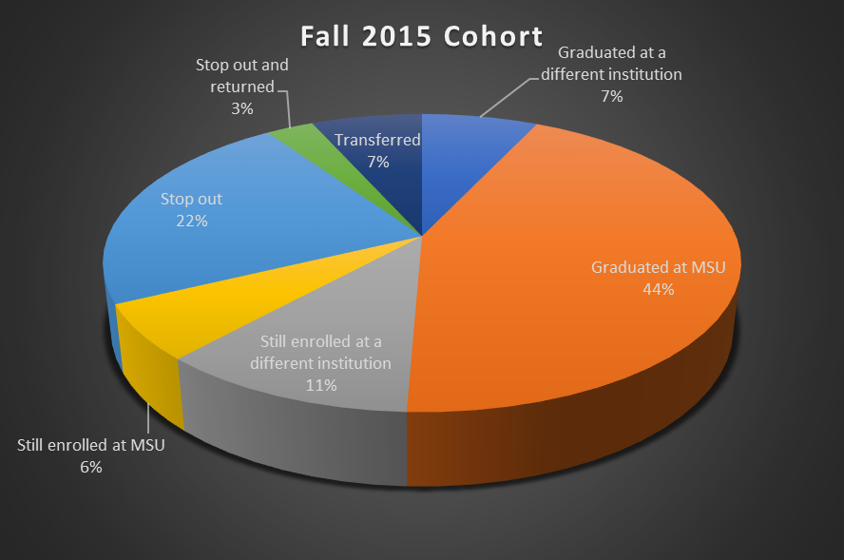

Fall 2015 Cohort | # | %
Graduated at a different institution | 22 | 7.01%
Graduated at MSU | 137 | 43.63%
Still enrolled at a different institution | 35 | 11.15%
Still enrolled at MSU | 19 | 6.05%
Stop out | 71 | 22.61%
Stop out and returned | 9 | 2.87%
Transferred | 21 | 6.69%
Grand Total | 314 | 100.00%

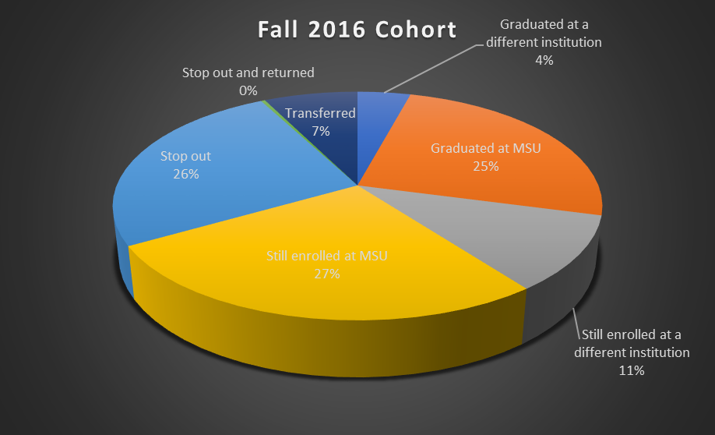

Fall 2016 Cohort | # | %
Graduated at a different institution | 13 | 4.17%
Graduated at MSU | 78 | 25.00%
Still enrolled at a different institution | 33 | 10.58%
Still enrolled at MSU | 84 | 26.92%
Stop out | 80 | 25.64%
Stop out and returned | 1 | 0.32%
Transferred | 23 | 7.37%
Grand Total | 312 | 100.00%

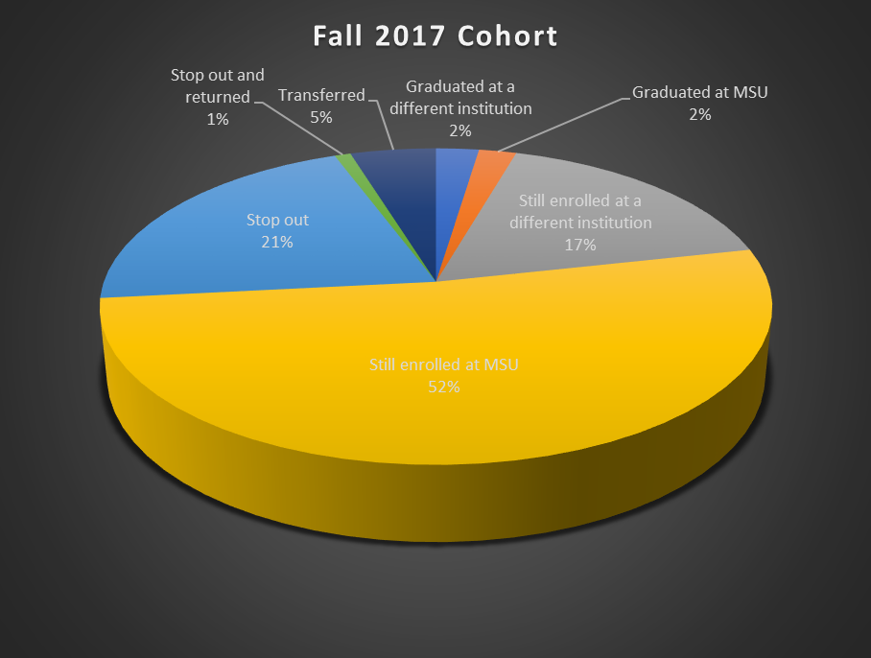

Fall 2017 Cohort | # | %
Graduated at a different institution | 8 | 2.40%
Graduated at MSU | 7 | 2.10%
Still enrolled at a different institution | 57 | 17.07%
Still enrolled at MSU | 173 | 51.80%
Stop out | 70 | 20.96%
Stop out and returned | 3 | 0.90%
Transferred | 16 | 4.79%
Grand Total | 334 | 100.00%

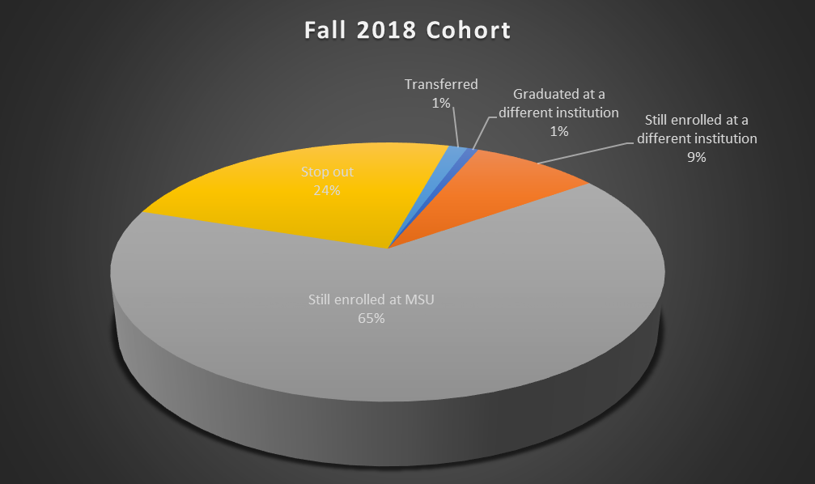

Fall 2018 Cohort | # | %
Graduated at a different institution | 3 | 0.78%
Still enrolled at a different institution | 34 | 8.85%
Still enrolled at MSU | 249 | 64.84%
Stop out | 93 | 24.22%
Transferred | 5 | 1.30%
Grand Total | 384 | 100.00%

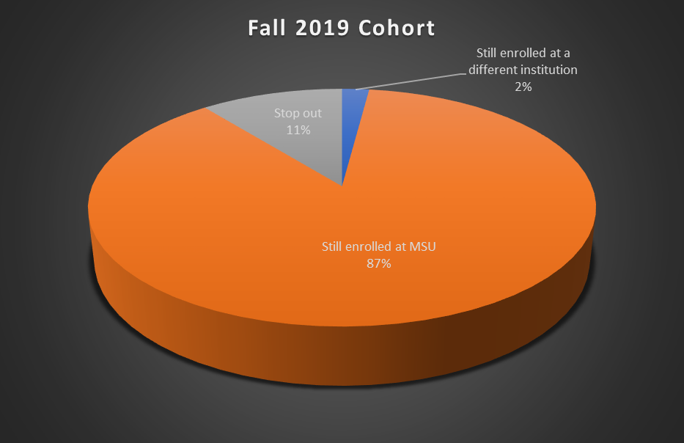
Fall 2019 Cohort | # | %
Still enrolled at a different institution | 8 | 2.05%
Still enrolled at MSU | 340 | 87.18%
Stop out | 42 | 10.77%
Grand Total | 390 | 100.00%

Fall to Spring Persistence Rate=87%

