**How to Access the NDUS Theft and Fraud Training**

1. Using Chrome or Firefox browser, navigate to: <https://blackboard.ndus.edu/>
2. Login using your NDUS credentials.

1. Click on the **Courses** tab along the top of the page.

1. Click on the NDUS Theft and Fraud course.

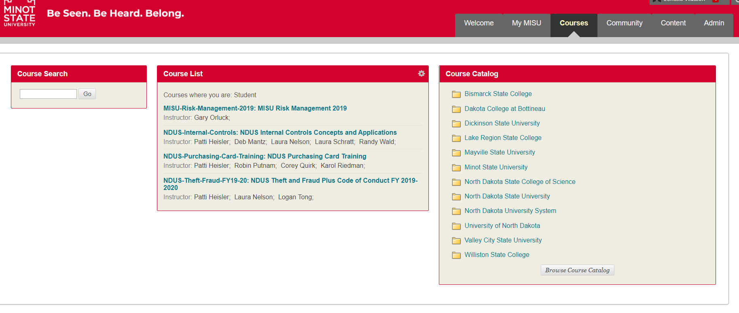

1. Complete steps 1 and 2 found on the left side of the screen.

