
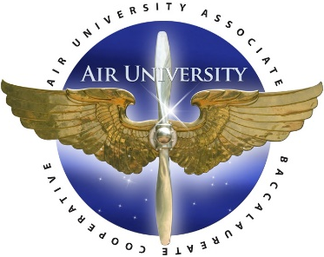

AU-ABC Bachelor of General Studies Agreement

(Category 1)

Minot State University is offering a Bachelor of General Studies (BGS) program plan to meet the needs of Community College of the Air Force (CCAF) graduates looking for advanced education opportunities at the baccalaureate level.
CCAF students with an AAS degree in any area are eligible to participate.
The Bachelor of General Studies degree includes the following degree requirements:
- General Education Coursework
- General Studies Requirements
- 120 Total Credits
Students considering completing this BGS degree are encouraged to contact an academic advisor at Minot State as early as possible to ensure maximum transferability and a smooth transition.

Sample Program Plan
Degree Requirement | Required  Semester Credits | CCAF Transfer Credits | Minot State Course Credits
Bachelor of General Studies Requirements | 37 |  | 37
300-400 level course work | 36 |  | 36
IDS 470 General Studies Capstone¹ | 1 |  | 1
CCAF Transfer Credit | 48 | 48
General Education (GE) Coursework | 35 | 12 | 23
GE Communication
CCAF Written Communication (ENGL 110 College Composition I) |  | 3
ENGL 120 College Composition II |  |  | 3
CCAF Oral Communication (COMM 110 Fundamentals of Public Speaking) |  | 3
GE Quantitative Reasoning
ND:MATH ² |  |  | 4
GE Fine Arts, Humanities, and History
CCAF Humanities |  | 3
ND:FA, ND:HUM, or ND:HIST |  |  | 3
GE Natural Sciences and Technology
ND:LABSC |  |  | 4
GE Social Science
CCAF Social Science |  | 3
ND: SS |  |  | 3
GE Choice
ND:ENGL, ND:DGTL, ND:COMM, ND:MATH, ND:FA, ND:HUM, ND:HIST,ND:LABSC, ND:SCI, ND:COMPSC, or ND:SS |  |  | 3
ND:ENGL, ND:DGTL, ND:COMM, ND:MATH, ND:FA, ND:HUM, ND:HIST,ND:LABSC, ND:SCI, ND:COMPSC, or ND:SS |  |  | 3
Total Credits Required³ | 120 | 60⁴ | 60

Additional Degree Requirements:
- A Bachelor of General Studies degree may not be earned in combination with another degree/major.
- Students may declare a minor (or minors), but not concentrations.
- A minimum of 120 total credits must be earned and a minimum 2.00 cumulative grade point average is required.
- A maximum of eight credits of Internship and/or Research coursework may be applied to the upper-level credit requirement.

Footnotes:
¹For students in the AU-ABC Bachelor of General Studies program plan, IDS 470 may be counted as part of the 300-400 level course work requirement.
²A Math course may be transferred if it is College Algebra or higher level.
³Students must take 30 credits from Minot State University.
⁴Credits earned through examination may not meet Minot State University requirements. Please see the NDUS Credit-By-Exam chart for accepted exams.

