Data Metrics

* Formed as a result of Strategic Enrollment Management (SEM) project
* Comprised of:
  + IR Office (Cari Olson)
  + Registrar’s Office (Rebecca Ringham)
  + Enrollment Services Office (Katie Tyler)
  + Center for Extended Learning (Jolina Miller)
  + Financial Aid Office (Laurie Weber)
* Cohort Analysis
  + The concept of this report is to track cohort student enrollment through graduation
  + Data Metrics found that although we have Hobson’s this only tracks Inquiry to 1st year enrollment
  + Due to lack of software Data Metrics creates this report manually
  + Summer 2020 the following cohorts were ran and compiled
    - 2015
    - 2015
    - 2016
    - 2017
    - 2018
    - 2020
  + Additional Variables were brought in:
    - Credits attempted
    - Credits completed
    - Retention
    - Graduation
    - Student Tracker- National Student Clearing House Information (ran summer 2021)
  + Data Metrics created a Student Status Column based on Student Tracker
    - Graduated at a different institution
    - Graduated at MSU
    - Still enrolled at a different institution
    - Still enrolled at MSU
    - Stopped Out
    - Stopped Out and Returned
    - Transferred to another institution
    - Deceased
* It is the intent of the Data Metrics team to update the Student Cohort each summer once graduation data has been processed and available through Student Tracker.

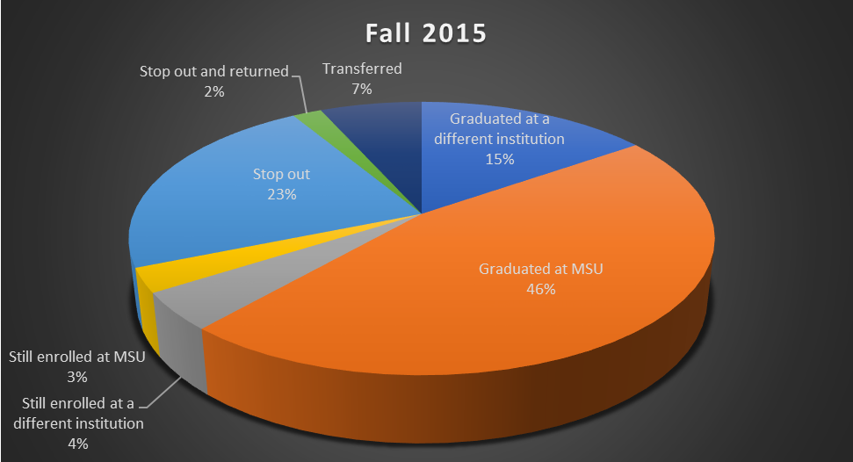



**6-year Graduation Rate=46%**

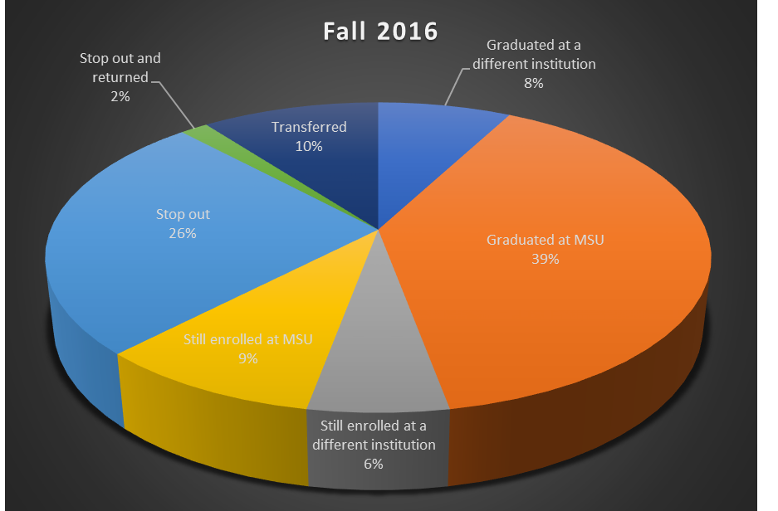



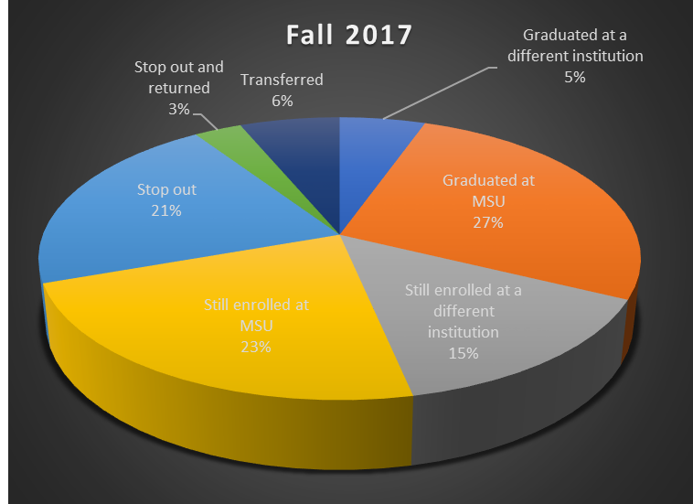



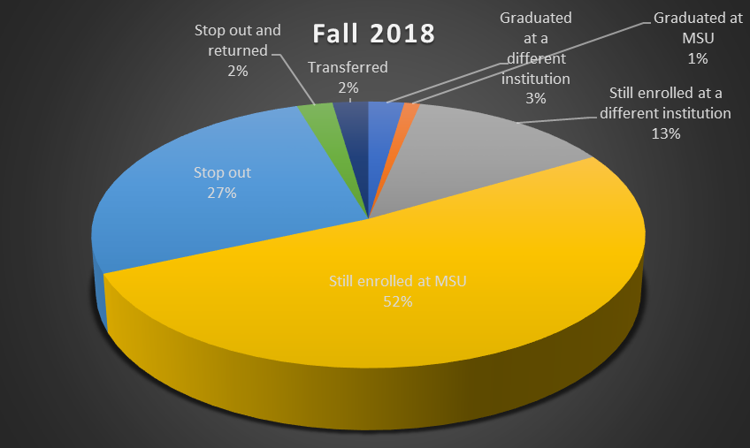



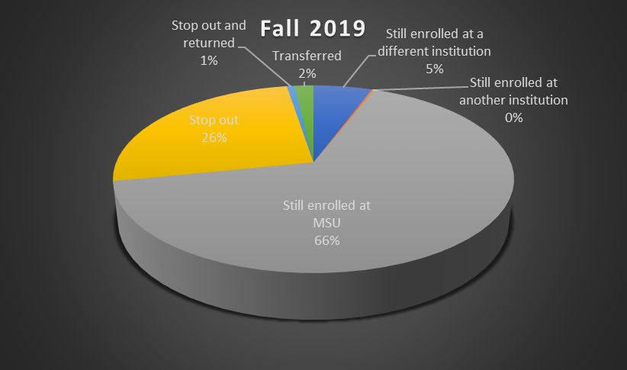



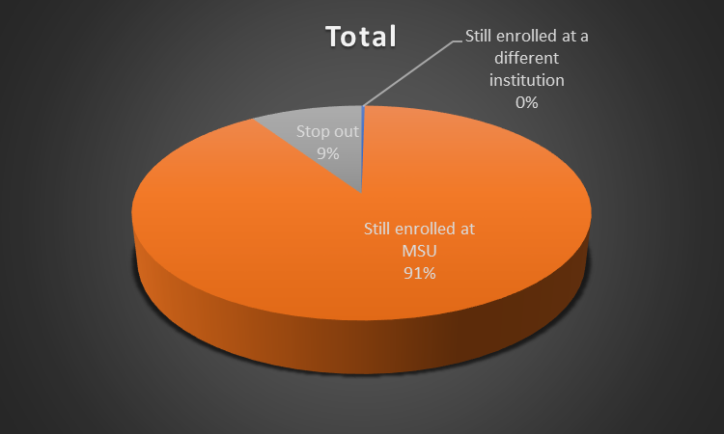



**Fall to Spring Persistence Rate=90.4%**