Payment Methods

On the last day of each month, students with a balance due to MSU will receive an email notification of their monthly billing statement. Instructions regarding how to view your electronic statement are below. Please note that monthly billing statements are a snapshot of a moment in time. The most accurate and up-to-date information regarding your student account balance may be found by logging in to Campus Connection and clicking on the Financial Account tile.
- Log in to Campus Connection and click on the Financial Account tile.

- Click on Pay Online Now and select MSU. You will then be routed to the online payment portal, Nelnet.

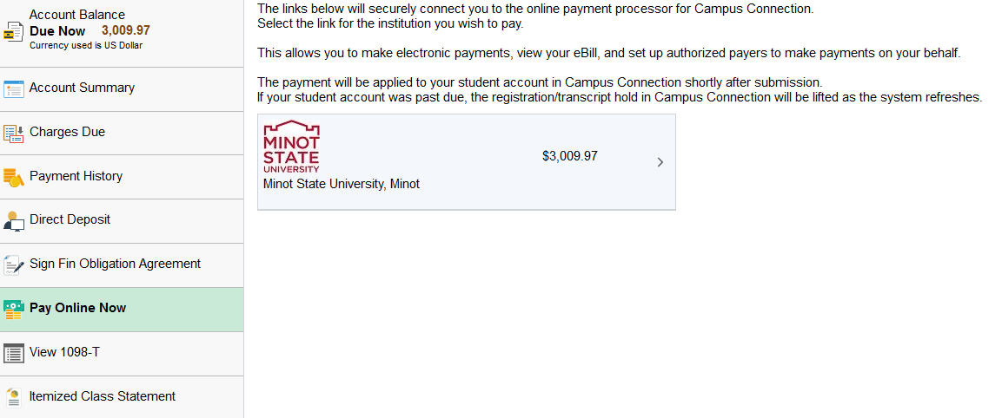

- click on View & Pay Accounts in the left-hand navigation menu
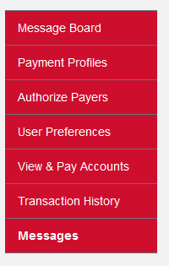

- In the upper right corner, click on the Statement Details or View PDF link.
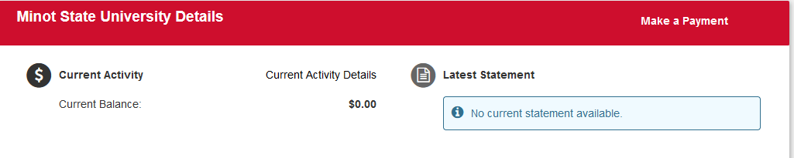

Questions? Contact the Business Office at studentinfobusoff@minotstateu.edu or 701-858-3333.

